

2025 Water Quality Report for Andrews Estates
Water Supply Serial Number: 40246
This report covers the drinking water quality for Andrews Estates for the 2025 calendar year. This information is a snapshot of the quality of the water that we provided to you in 2025. Included are details about where your water comes from, what it contains, and how it compares to United States Environmental Protection Agency (U.S. EPA) and state standards.
Your water comes from 3 groundwater wells, each over 40 feet deep. The State performed an assessment of our source water to determine the susceptibility or the relative potential of contamination. The susceptibility rating is on a seven-tiered scale from "very-low" to "very-high" based on geologic sensitivity, well construction, water chemistry and contamination sources. The susceptibility of our source is well 1 is HIGH, well 2 is MODERATELY HIGH, and well 3 is MODERATE.
There are no significant sources of contamination in our water supply. We are making efforts to protect our sources by monthly and annual water sampling to identify any contamination.
If you would like to know more about this report, please contact: Bryan Free, LGC Communities, 12034 E Michigan Ave, Galesburg MI 49053, 269-377-5140, Free.bryan@yahoo.com, lgccommunities.com.
Contaminants and their presence in water: Drinking water, including bottled water, may reasonably be expected to contain at least small amounts of some contaminants. The presence of contaminants does not necessarily indicate that water poses a health risk. More information about contaminants and potential health effects can be obtained by calling the U.S. EPA’s Safe Drinking Water Hotline (800-426-4791).
Vulnerability of sub-populations: Some people may be more vulnerable to contaminants in drinking water than the general population. Immuno-compromised persons such as persons with cancer undergoing chemotherapy, persons who have undergone organ transplants, people with HIV/AIDS or other immune systems disorders, some elderly, and infants can be particularly at risk from infections. These people should seek advice about drinking water from their health care providers. U.S. EPA/Center for Disease Control guidelines on appropriate means to lessen the risk of infection by Cryptosporidium and other microbial contaminants are available from the Safe Drinking Water Hotline (800-426-4791).
Sources of drinking water: The sources of drinking water (both tap water and bottled water) include rivers, lakes, streams, ponds, reservoirs, springs, and wells. Our water comes from wells. As water travels over the surface of the land or through the ground, it dissolves naturally-occurring minerals and, in some cases, radioactive material, and can pick up substances resulting from the presence of animals or from human activity.
Contaminants that may be present in source water include:
- Microbial contaminants, such as viruses and bacteria, which may come from sewage treatment plants, septic systems, agricultural livestock operations and wildlife.
- Inorganic contaminants, such as salts and metals, which can be naturally-occurring or result from urban stormwater runoff, industrial or domestic wastewater discharges, oil and gas production, mining or farming.
- Pesticides and herbicides, which may come from a variety of sources such as agriculture and residential uses.
- Radioactive contaminants, which can be naturally occurring or be the result of oil and gas production and mining activities.
- Organic chemical contaminants, including synthetic and volatile organic chemicals, which are by-products of industrial processes and petroleum production, and can also come from gas stations, urban stormwater runoff, and septic systems.
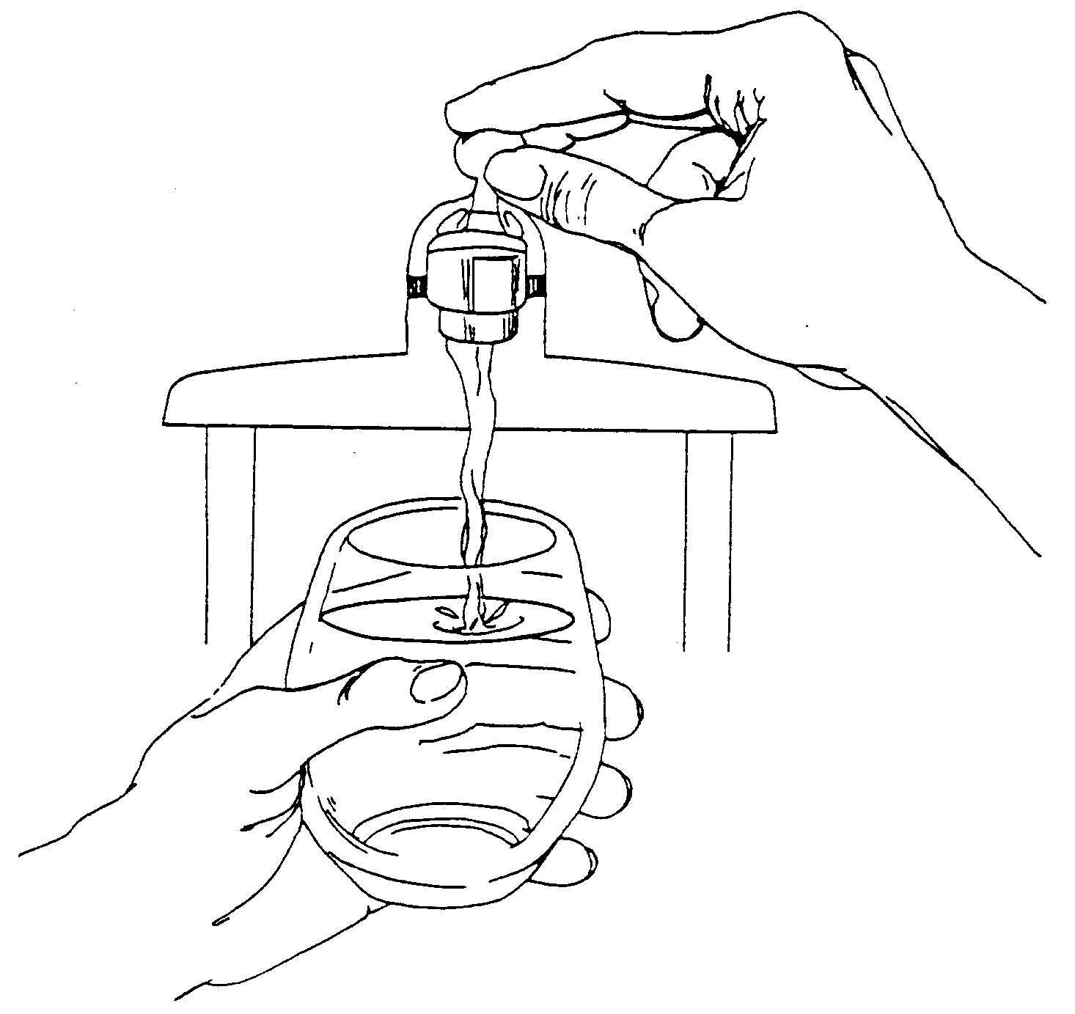
In order to ensure that tap water is safe to drink, the U.S. EPA prescribes regulations that limit the levels of certain contaminants in water provided by public water systems. Federal Food and Drug Administration regulations establish limits for contaminants in bottled water which provide the same protection for public health.

Water Quality Data
The table below lists all the drinking water contaminants that we detected during the 2025 calendar year. The presence of these contaminants in the water does not necessarily indicate that the water poses a health risk. Unless otherwise noted, the data presented in this table is from testing done January 1 through December 31, 2025. The State allows us to monitor for certain contaminants less than once per year because the concentrations of these contaminants are not expected to vary significantly from year to year. All the data is representative of the water quality, but some are more than one year old.

Terms and abbreviations used below:
- Maximum Contaminant Level Goal (MCLG): The level of a contaminant in drinking water below which there is no known or expected risk to health. MCLGs allow for a margin of safety.
- Maximum Contaminant Level (MCL): The highest level of a contaminant that is allowed in drinking water. MCLs are set as close to the MCLGs as feasible using the best available treatment technology.
- Maximum Residual Disinfectant Level (MRDL): The highest level of a disinfectant allowed in drinking water. There is convincing evidence that addition of a disinfectant is necessary for control of microbial contaminants.
- Maximum Residual Disinfectant Level Goal (MRDLG): The level of a drinking water disinfectant below which there is no known or expected risk to health. MRDLGs do not reflect the benefits of the use of disinfectants to control microbial contaminants.
- Treatment Technique (TT): A required process intended to reduce the level of a contaminant in drinking water.
- N/A: Not applicable
- ND: not detectable at testing limit
- ppm: parts per million or milligrams per liter
- ppb: parts per billion or micrograms per liter
- ppt: parts per trillion or nanograms per liter
- pCi/l: picocuries per liter (a measure of radioactivity)
- Action Level (AL): The concentration of a contaminant which, if exceeded, triggers treatment or other requirements that a water system must follow.
- Level 1 Assessment: A study of the water supply to identify potential problems and determine (if possible) why total coliform bacteria have been found in our water system.
- Level 2 Assessment: A very detailed study of the water system to identify potential problems and determine (if possible) why an E. coli MCL violation has occurred and/or why total coliform bacteria have been found in our water system on multiple occasions.

1Monitoring Data for Regulated Contaminants

Regulated Contaminant | MCL, TT, or MRDL | MCLG or MRDLG | Level Detected | Range | Year Sampled | Violation Yes/No | Typical Source of Contaminant
Barium (ppm) | 2 | 2 | .06 | N/A | 2016 | NO | Discharge of drilling wastes; Discharge of metal refineries; Erosion of natural deposits
Nitrate (ppm) | 10 | 10 | N/D | N/A | 2025 | NO | Runoff from fertilizer use; Leaching from septic tanks, sewage; Erosion of natural deposits
Fluoride (ppm) | 4 | 4 | .18 | N/A | 2024 | NO | Erosion of natural deposits; Water additive which promotes strong teeth; Discharge from fertilizer and aluminum factories
Sodium (ppm) | N/A | N/A | 4.5 | N/A | 2024 | NO | Erosion of natural deposits
Alpha emitters (pCi/L) | 15 | 0 | .630 | N/A | 2023 | NO | Erosion of natural deposits
Combined radium (pCi/L) | 5 | 0 | N/D | N/A | 2022 | NO | Erosion of natural deposits
Uranium (ppb) | 30 | 0 | .0007 | N/A | 2024 | NO | Erosion of natural deposits
Total Coliform | TT | N/A | N/D | N/A | 2025 | NO | Naturally present in the environment
E. coli in the distribution system (positive samples) | See E. coli note | 0 | N/D | N/A | 2025 | NO | Human and animal fecal waste
Fecal Indicator – E. coli at the source (positive samples) | TT | N/A | N/D | N/A | 2025 | NO | Human and animal fecal waste

Per- and polyfluoroalkyl substances (PFAS)
Regulated Contaminant | MCL, TT, or MRDL | MCLG or MRDLG | Level Detected | Range | Year Sampled | Violation Yes/No | Typical Source of Contaminant
Hexafluoropropylene oxide dimer acid (HFPO-DA) (ppt) | 370 | N/A | N/D | N/A | 2025 | NO | Discharge and waste from industrial facilities  utilizing the Gen X chemical process
Perfluorobutane sulfonic acid (PFBS) (ppt) | 420 | N/A | N/D | N/A | 2025 | NO | Discharge and waste from industrial  facilities; stain-resistant treatments
Perfluorohexane sulfonic acid (PFHxS) (ppt) | 51 | N/A | N/D | N/A | 2025 | NO | Firefighting foam; discharge and waste  from industrial facilities
Perfluorohexanoic acid (PFHxA) (ppt) | 400,000 | N/A | N/D | N/A | 2025 | NO | Firefighting foam; discharge and waste  from industrial facilities
Perfluorononanoic acid (PFNA) (ppt) | 6 | N/A | N/D | N/A | 2025 | NO | Discharge and waste from industrial  facilities; breakdown of precursor compounds
Perfluorooctane sulfonic acid (PFOS) (ppt) | 16 | N/A | N/D | N/A | 2025 | NO | Firefighting foam; discharge from electroplating facilities; discharge and waste  from industrial facilities
Perfluorooctanoic acid (PFOA) (ppt) | 8 | N/A | N/D | N/A | 2025 | NO | Discharge and waste from industrial  facilities; stain-resistant treatments
Inorganic Contaminant Subject to Action Levels (AL) | Action Level | MCLG | Your Water | Range of Results | Year Sampled | Number of Samples Above AL | Typical Source of Contaminant
Lead (ppb) | 12 | 0 | N/D | N/A | 2023 | 0 | Lead service lines, corrosion of household plumbing including fittings and fixtures; Erosion of natural deposits
Copper (ppm) | 1.3 | 1.3 | N/D | N/A | 2023 | 0 | Corrosion of household plumbing systems; Erosion of natural deposits

Information about lead: Lead can cause serious health effects in people of all ages, especially pregnant people, infants (both formula-fed and breastfed), and young children. Lead in drinking water is primarily from materials and parts used in service lines and in home plumbing. Andrews Estates (LCG Communities) is responsible for providing high quality drinking water and removing lead pipes but cannot control the variety of materials used in the plumbing in your home. Because lead levels may vary over time, lead exposure is possible even when your tap sampling results do not detect lead at one point in time. You can help protect yourself and your family by identifying and removing lead materials within your home plumbing and taking steps to reduce your family's risk. Using a filter, certified by an American National Standards Institute accredited certifier to reduce lead, is effective in reducing lead exposures. Follow the instructions provided with the filter to ensure the filter is used properly. Use only cold water for drinking, cooking, and making baby formula. Boiling water does not remove lead from water. Before using tap water for drinking, cooking, or making baby formula, flush your pipes for several minutes. You can do this by running your tap, taking a shower, doing laundry or a load of dishes. If you have a lead service line or galvanized requiring replacement service line, you may need to flush your pipes for at least 5 minutes to flush water from both your home plumbing and the lead service line. If you are concerned about lead in your water and wish to have your water tested, contact LCG Communities (Bryan Free) at 269-377-5140 for available resources. Information on lead in drinking water, testing methods, and steps you can take to minimize exposure is available at https://www.epa.gov/safewater/lead.

Monitoring and Reporting to the Department of Environment, Great Lakes, and Energy (EGLE) Requirements: The State of Michigan and the U.S. EPA require us to test our water on a regular basis to ensure its safety. We met all the monitoring and reporting requirements for 2025.
We will update this report annually and will keep you informed of any problems that may occur throughout the year, as they happen. Copies are available at LGC Communities main office at 12034 E Michigan Ave, Galesburg MI 49053. Please call 269-377-5140 to obtain a copy from here as the office is not always open.
We invite public participation in decisions that affect drinking water quality. For more information about your water, or the contents of this report, contact Bryan Free at 269-377-5140 or free.bryan@yahoo.com. You can also see this on our website, www.lcgcommunities.com under the Andrews Estates Tab. For more information about safe drinking water, visit the U.S. EPA at http://www.epa.gov/safewater.

Sodium is not a regulated contaminant.
E. coli MCL violation occurs if: (1) routine and repeat samples are total coliform-positive and either is E. coli-positive, or (2) the supply fails to take all required repeat samples following E. coli-positive routine sample, or (3) the supply fails to analyze total coliform-positive repeat sample for E. coli.
Ninety (90) percent of the samples collected were at or below the level reported for our water.

